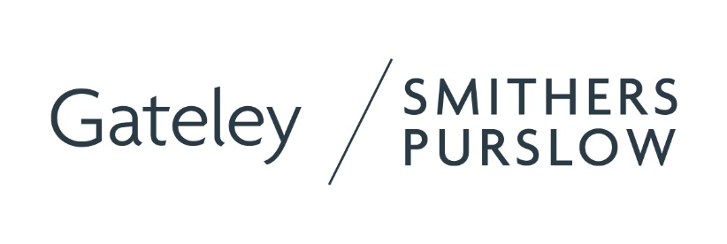

**Gateley Smithers Purslow to exhibit at BIBA 2025**

Gateley Smithers Purslow (GSP) is pleased to be returning to the annual British Insurance Brokers’ Association (BIBA) conference and exhibition on Wednesday 14 and Thursday 15 May 2024 at Manchester Central Convention Complex. Visitors will be able to meet with the GSP team on stand A60 throughout the two-day event.

**Gateley Smithers Purslow**

A multi-disciplinary surveying, engineering and architecture consultancy servicing the insurance, residential and commercial sectors from its network of 19 UK offices.

Comprising chartered building and quantity surveyors, civil and structural engineers, and architecture and planning specialists, its nationwide team of 190 experts work collaboratively to deliver full-service solutions from the initial assessment of property damage and issues, through to the full management of repairs and rebuild projects.

**Insurance claim specialists**

GSP specialises in resolving buildings insurance claims focussing on major, high-net worth and complex loss, legal disputes and recoveries, and unique forms of construction.

Its expert teams act for insurance companies, loss adjusters, risk managers, brokers, local authorities, housing associations, lawyers and policyholders, and has extensive experience in assessing damage for domestic and commercial properties and resolving a wide range of perils including fire, flood, storm, impact, accidental damage, escape of water, subsidence, heave and landslip. This includes advising on heritage and conservation matters for listed buildings and providing solutions in line with conservation guidance.

**A leader within the construction and insurance sectors**

In 2024, as part of a joint submission, GSP was shortlisted as a finalist in the Major Loss category at The British Insurance Awards 2024 hosted by Insurance Post.

GSP holds a Certified Carbon Neutral Status demonstrating its commitment to being an industry leader without compromising on its environmental impact. It also holds ISO 14001 certification, the international standard for environmental management systems.

In addition to industry practices, the consultancy has successfully retained platinum status of the Investors in People ‘We invest in people’ accreditation, demonstrating its commitment to creating and maintaining an engaging, supportive and productive workplace culture.

Website: <https://www.gateleysmitherspurslow.com/>

Office locations and contact details: <https://www.gateleysmitherspurslow.com/contact/>