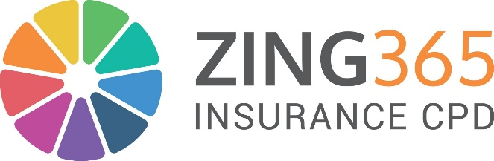

Zing365 Total CPD
Zing365 Launches Total CPD Solution
Zing365, a leading provider of training and development solutions, is proud to announce the launch of Zing Total CPD, a comprehensive learning and compliance solution designed to empower individuals and businesses across the Insurance industry. The Total CPD solution brings together cutting-edge technology, expert-led content, and seamless delivery options to meet the evolving Continuing Professional Development needs of today’s insurance professionals.
At the heart of Zing Total CPD is a world-class LMS tailored specifically for the Insurance Sector. This innovative portal offers access to our full insurance e-learning content library and our full calendar of live online webinars, while enabling seamless FCA CPD reporting to ensure compliance with regulatory standards. With white-label capability, businesses can personalise the platform to reflect their brand identity and offer a consistent, professional learning experience.
Zing Total CPD is designed to futureproof learning strategies in an industry where regulation, customer expectations, and market conditions are constantly evolving. Whether you’re an individual looking to advance your career or an organisation aiming to streamline CPD and compliance, Zing365 provides a single, trusted solution.
“Total CPD is more than a learning system—it’s a strategic partner for CPD excellence in the insurance sector,” said Fran Burgess CEO at Zing365. “We’ve developed a flexible and scalable solution that supports individuals at every stage of their professional development, while helping organisations meet governance and compliance obligations with ease.”
While Total CPD is our all in one, holistic CPD solution, Zing365 also allow companies to access the separate components individually such as:
Zing Content - Enabling organisations to license Zing365’s high-quality e-learning materials, giving them direct access to expertly developed modules in Governance, Risk & Compliance, General Insurance, and ESG & Sustainability. This allows internal teams to integrate best-in-class training into their own platforms or use them as standalone resources.
Zing Live - For professionals who thrive on real-time interaction and current insights, Zing Live offers over 150 live online webinars per year, delivered by industry experts. Topics span insurance, compliance, and soft skills, providing ongoing learning that’s engaging, timely, and impactful.
Zing Live Bespoke - Recognising the need for customised learning experiences, Zing Live Bespoke delivers tailored webinars and workshops, available both online and in-person, on themes such as General Insurance, Leadership & Management, and Compliance. These bespoke sessions are ideal for teams with specific goals, regulatory requirements, or professional development plans.

