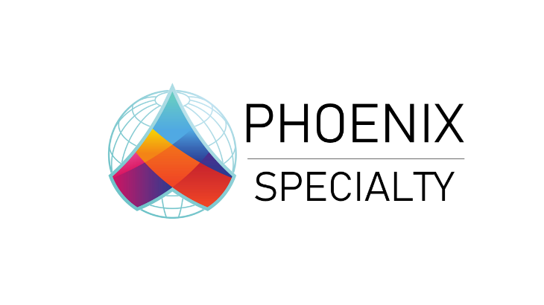
Phoenix Specialty Heads to BIBA 2025 with Major Global Launch
Stand F77 | BIBA Conference, Manchester | May 2025
Phoenix Specialty is proud to announce our participation in this year’s BIBA Conference as an exhibitor at Stand F77. We’re excited to connect with broker partners and industry colleagues—and to share some major news shaping our future.

About Phoenix Specialty
Phoenix Specialty is a specialist MGA delivering smart, tailored insurance solutions for the construction and engineering sectors. Founded in 2024, we operate across the UK and Ireland, combining deep industry insight with a hands-on, responsive approach.
We believe insurance is built on relationships. That’s why we prioritise long-term partnerships with brokers—because your success is our success. Our experienced team brings technical expertise and a people-first mindset to every interaction.
At Phoenix, we don’t just provide cover—we provide confidence. From Contractors' All Risks to Liability and beyond, we deliver clarity, consistency, and commitment with every policy. Backed by secure capacity and driven by specialist underwriters, Phoenix Specialty is your partner in navigating complex construction risks and achieving the best outcomes for your clients.

Global Expansion: Launching Our Contractors’ Plant and Equipment (CPE) Product
As part of our international growth journey, we are thrilled to announce the official launch of our Global Contractors’ Plant and Equipment (CPE) offering. This specialist product enhances our construction proposition and demonstrates our commitment to technical excellence, sustainable practices, and profitable underwriting.
We also welcome Paul Kissane as Head of Global CPE. With over 20 years of experience at Castel, Pioneer Underwriters, and WRB, Paul brings the leadership and market expertise to drive this new initiative forward.
CPE Product Highlights:
- Annual renewable business
- Direct insurance or facultative reinsurance
- Owned and hired-in plant – above & underground
- Lead or follow lines
Target Portfolios:
- $150m–$500m asset schedules
- Proven safety and maintenance standards
Since our launch in 2024, Phoenix has focused on building strong global partnerships—and 2025 marks a pivotal year as we expand our international presence.

Let’s Meet at BIBA
Come meet the team at Stand F77 to learn more about how we can support you and your clients—across construction, engineering, and beyond. There are still a few meeting slots available, so don’t miss your chance to connect with us during the event.
See you in Manchester!

