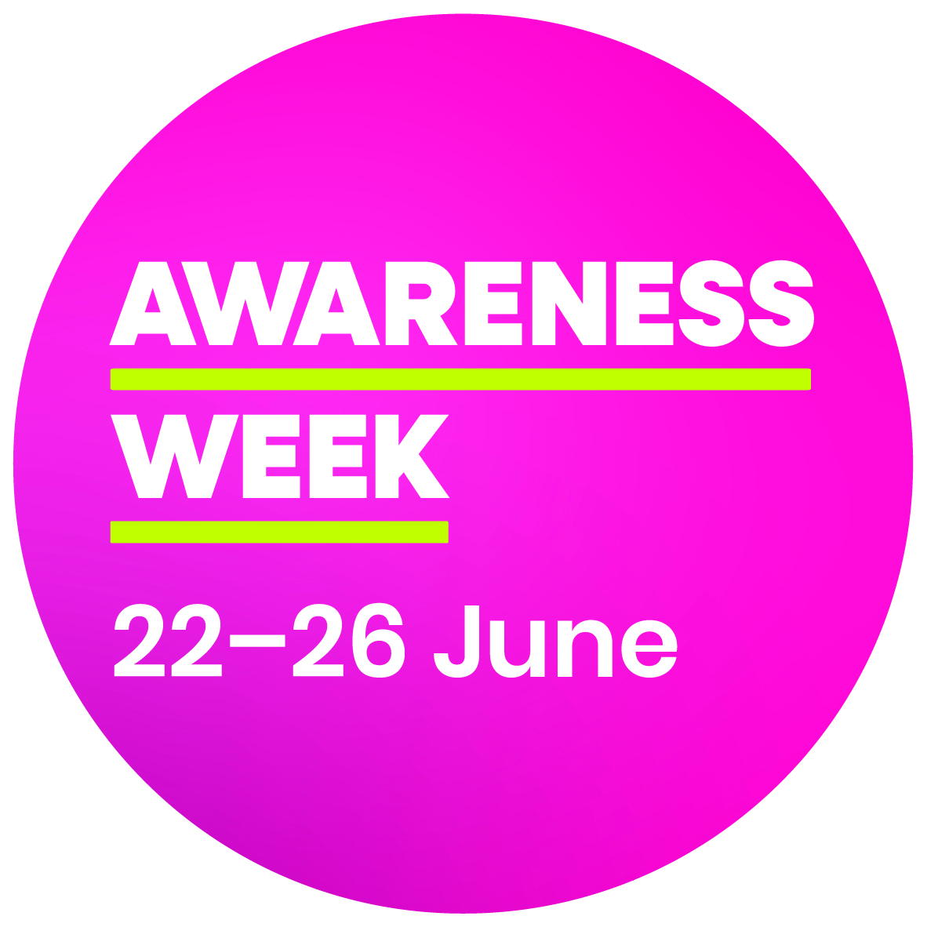
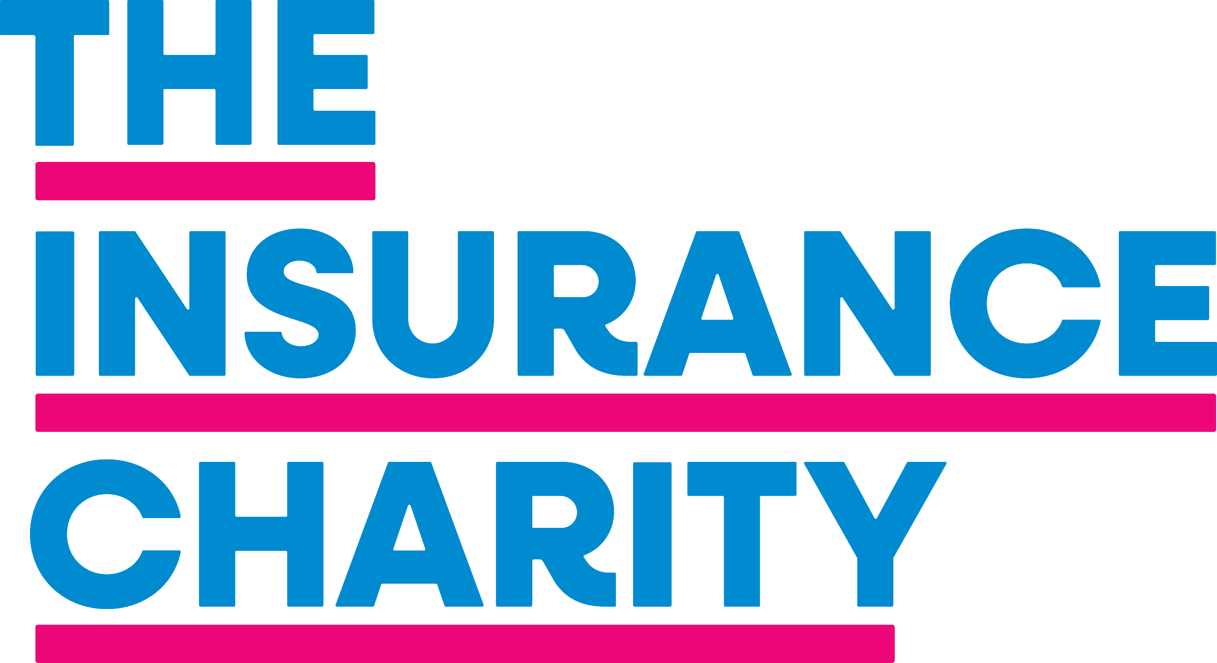

We’re pleased to confirm that Insurance Charity Awareness Week (ICAW) will run from 22 to 26 June this year.
Our annual awareness campaign aims to boost our profile among the insurance community and ensure that no-one in need of support misses out. In addition, we want to demonstrate the impact we have on insurance people and their families.
Please make a note in your diaries, and where appropriate let your Comms/Marketing/CSR teams know, so they can schedule ICAW activity alongside any other initiatives taking place.
We’re hoping to make this year’s campaign bigger and better than ever, so please help us spread the word by getting involved in any way you can. We’ll be issuing free giveaways, offering online presentations throughout the week and providing an online Supporter Toolkit nearer the time, so please look out for further details.
Please follow us on social media for updates and sign up for our enewsletter at the bottom of our homepage if you haven’t yet registered.
LinkedIn: www.linkedin.com/company/the-insurance-charity
Website: www.theinsurancecharity.org.uk
If you have any other queries, you can call us on 020 7606 3763 or email marketing@theinsurancecharity.org.uk.

